Practical 2 code

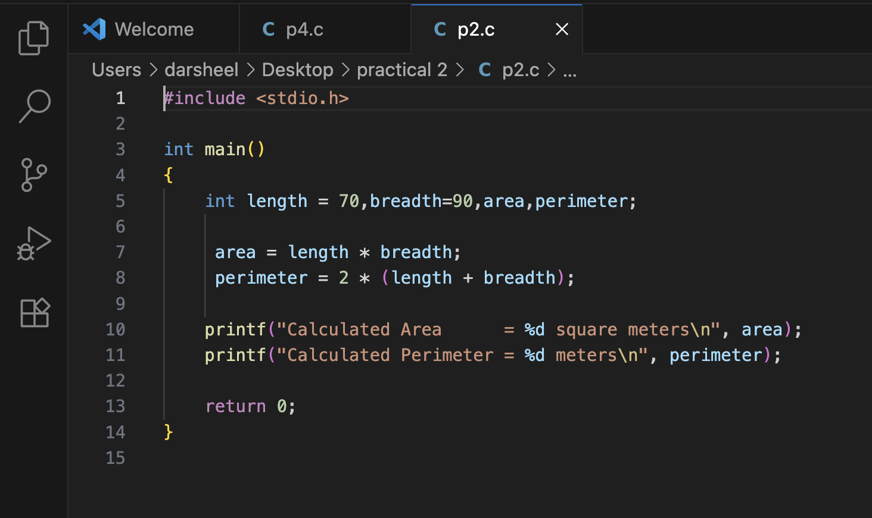

Output of the code

